**SERVER CREATION**

**Installing nginx in the virtual machine:**

Command:

apt update – for updating

apt install nginx – To install nginx

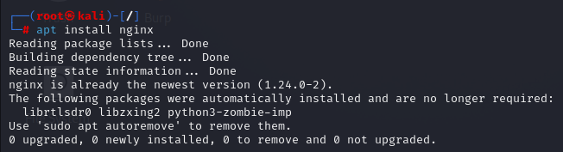

Figure: 1

**Adding html code in nginx html**

Adding html code in the path -- /var/www/html

Command: /var/www/html/<filename>

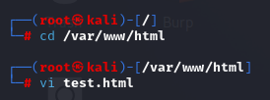

Figure: 2

Command:

vi test.html

HTML Code:

<head>

Test Server

</head>

<body>

<h1> This is a test server </h1>

</body>

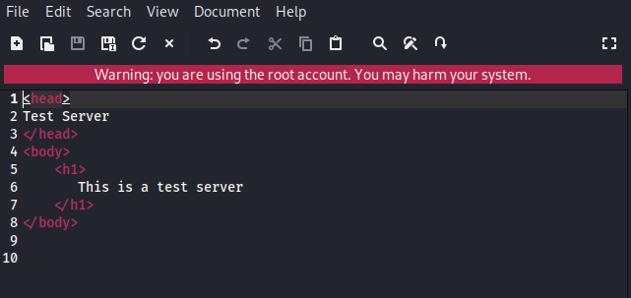

Figure: 3

**Finding IP address:**

Command: ip addr

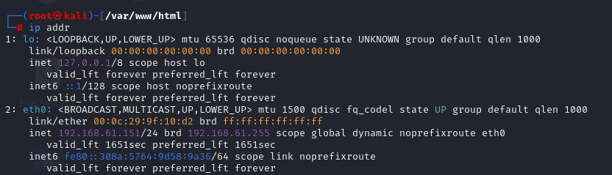

Figure: 4

**Changing the hostname:**

Command: hostnamectl set-hostname <hostname>

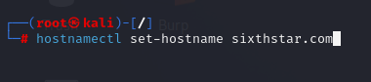

Figure: 5

**Changing the hosts:**

Command: vi /etc/hosts

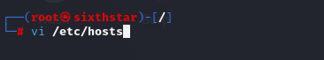

Figure: 6

192.168.147.182 Sixthstar.com

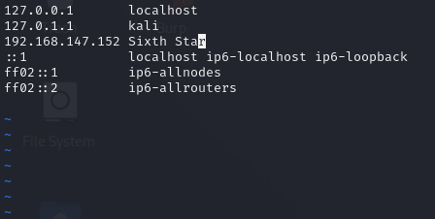

Figure: 7

**Enabling the nginx**

Command: systemctl enable nginx

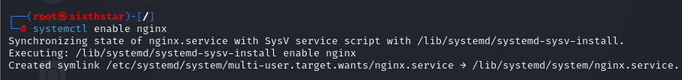

Figure: 8

**Starting the nginx service**

Command: systemctl start nginx

**Checking the nginx status**

Command: systemctl status nginx

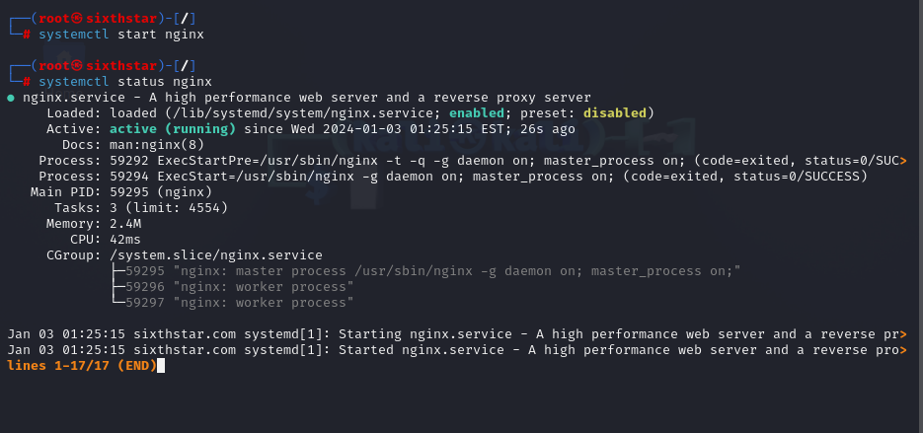

Figure: 9

**Checking the service**

Curl <http://192.168.61.151/test.html>

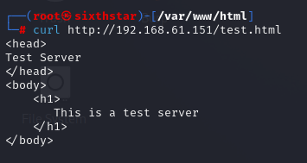

Figure: 10

Or

Open the browser and paste the URL – <http://192.168.61.151/test.html>

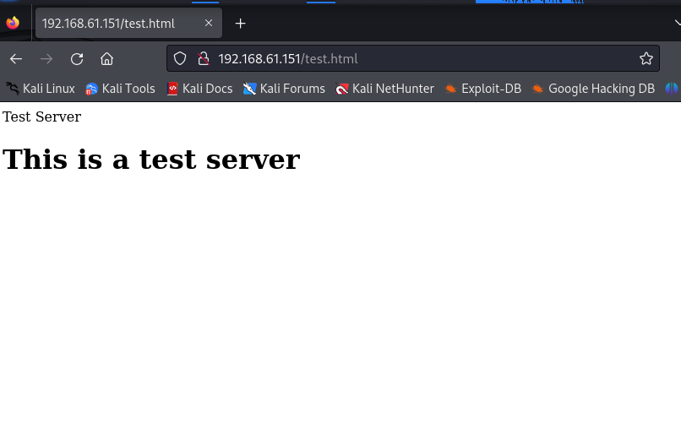

Figure: 11

**Wireshark:**

Wireshark is a popular open-source network protocol analyzer. It is used for troubleshooting, analysis, development and education in the field of network communication. Wireshark allows users to capture and inspect the data traveling back and forth on a network in real-time.

**Traffic Capturing:**

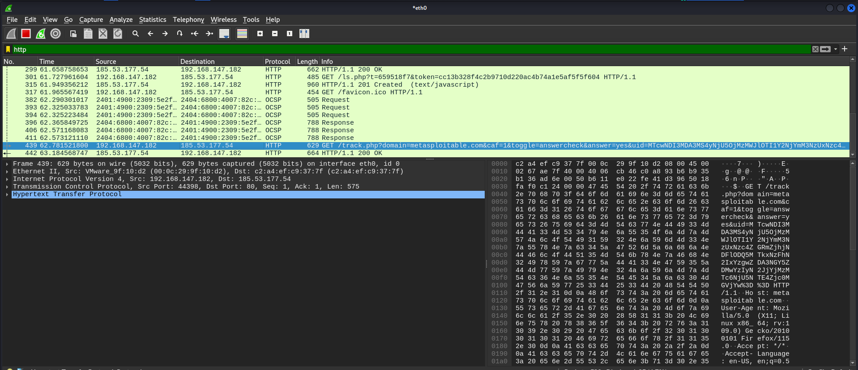

Figure: 12

By selecting ‘http’ only option it will show the traffic related to the HTTP requests and responses.

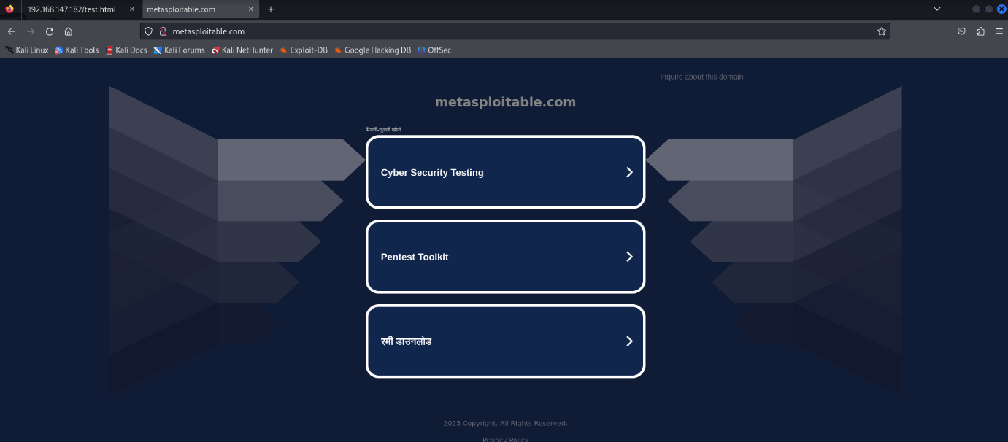

Figure: 13

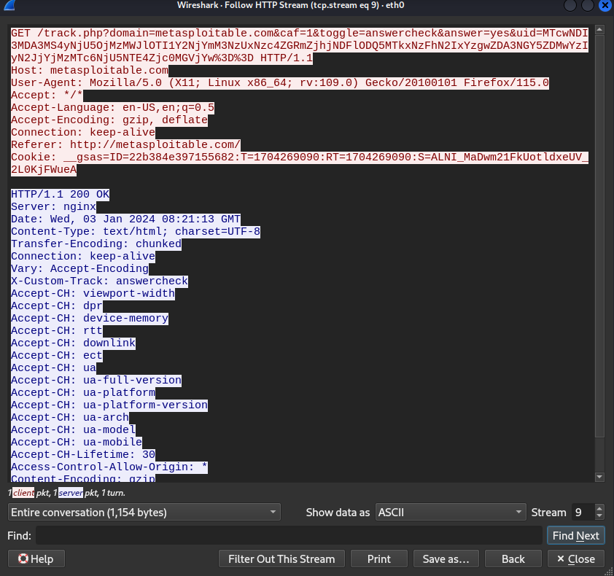

Figure: 14